Chapter-1

Study of Existing system and system requirements.
Hardware & Software Requirement:

Hardware Interfaces
- Minimum Hardware requirement
- Processor: P4 3.0 GHz
- RAM:1 GB or Higher
- Monitor
- Mouse
- Hard disk: 80 GB

Software Interfaces
- Minimum Software requirement
- Spring Boot
- Spring MVC
- Java (JSP and Servlet)

- Apache Tomcat Server
All these types of software automatic configure inside operating system after installation it having Java, MYSQL, Apache and operating system base configuration file, it doesn’t need to configure manually.
Introduction

As we know, in this world of technology, everything is being computerized with a large number of people using the internet in day-to-day activity. So, we should have a system to handle the activity of the airport or we can say to manage airport effectively. For that, I have developed an Airport Management System.

This application is designed and developed to support multi-user. It has a single login for Admin, Manager, and Pilot. Admin has the responsibility to add Planes, add Hanger, and add resources such as waypoints, departure, and destination. Another user here is the Pilot whose responsibility is to update flight plans such as pre-flight and post-flight. Another role in the system is that of the Manager who will allot planes to Hanger, update Hanger status.

This application will not only help the users but also the manager as well as the Admin and everyone can have a common medium to be connected.
Objective
The main objective of this project is to create a secured, robust airport management system. Here, all the information on Planes, Flight checklist, Hanger is available to every user 24*7.

Here, Admin is the main user of this application and whose responsibility is to add planes, add Hanger, add resources, add a schedule for the pilots, and so on. The other role is that of the pilot who can add a flight plan using this application. The manager on the other hand can manage all the pilot, plane, Hanger effectively using Our application.

Methodologies

There are three main users of this application one is the Admin, the other is the Owner and the last one is User.
1) Admin
- Admin can VIEW/ADD/UPDATE/DELETE Plane.
- Admin can VIEW/UPDATE/DELETE Pilot
- Admin can VIEW/UPDATE/DELETE Manager.
- Admin can VIEW/ADD/UPDATE/DELETE Hanger.
- Admin can ADD Waypoints.
- Admin can ADD Destination Location.
- Admin can ADD Departure Location.
- Admin can ADD Work Schedule for the pilot.

2) Pilot
- Pilot can ADD/VIEW Flight Plan
- Pilot can ADD/VIEW Help Report.
- Pilot can VIEW Work Schedule.
- Pilot can ADD/VIEW Pre-Flight mode list.
- Pilot can ADD/VIEW Post-Flight mode list.
3) Manager
- Manager can VIEW Hanger List.
- Managers can Allocate Hanger to Plane.
- Manager can update Hanger Status.
- Manager can resolve Help query.
- Manager can VIEW Pre-Flight mode check list.
- Pilot can VIEW Post-Flight mode check list.
Note: The login, registration and change password is common to all the user in the system.
Chapter-2
System Analysis
2.1 E R DIAGRAM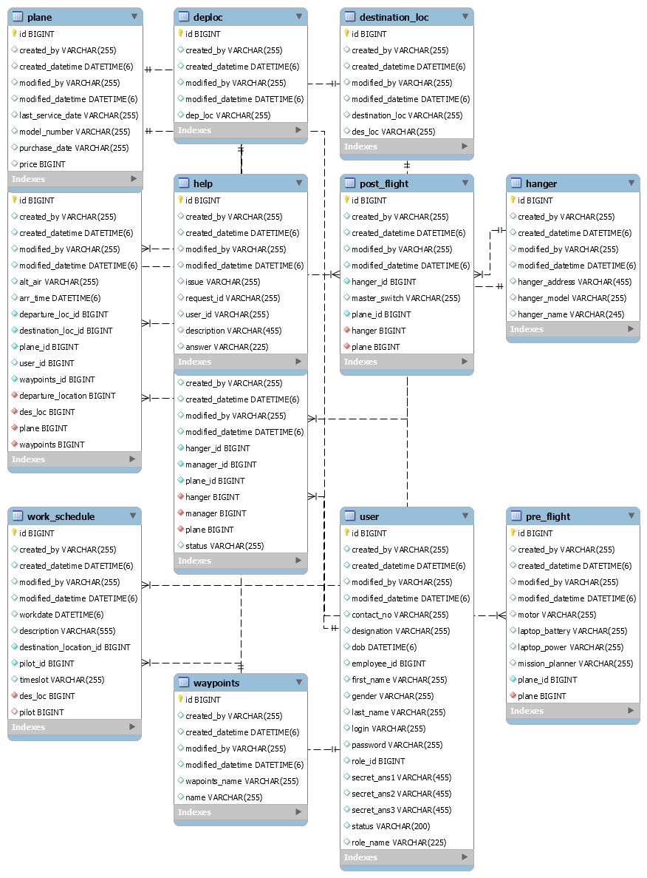

Data Flow Diagram (DFD)
Level 0:
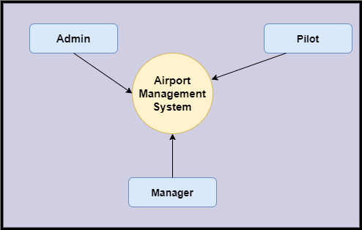
Level 1
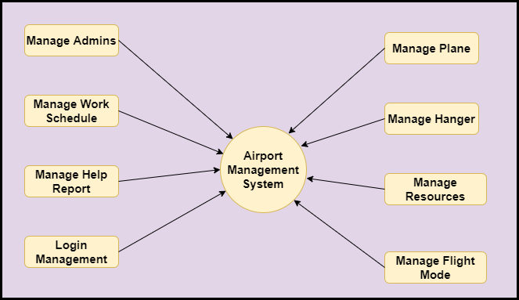

Level 2-DFD Admin
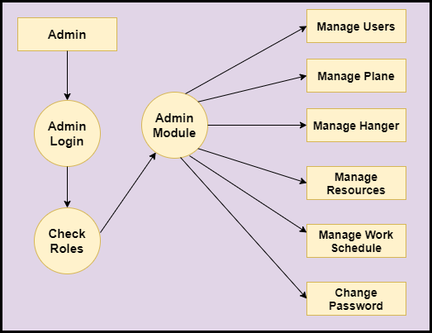
Level 2-DFD Pilot
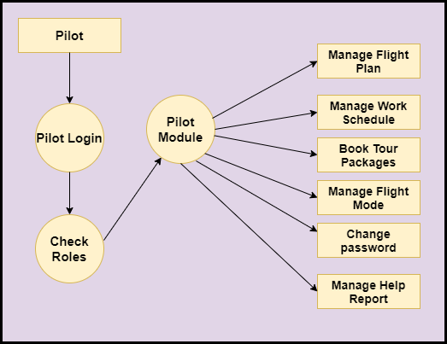
Level 2-DFD Manager
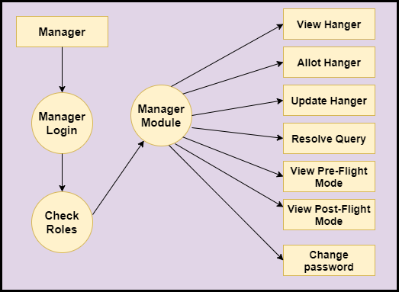
Feasibility:
This project will be developed on computer, so first check whether the technology is technically available or not. Now a day’s computer interaction with any job becomes common for any kind of job or work.

And because of increasing usage of Computer, Computer is also available with a variety of hardware. Vendors can fulfill any type of hardware requirement. The whole project is developed by some special tools or by using languages and databases, which are also available in a variety.

Preliminary investigation of a system examines the feasibility of a system that is useful to an organization. It is the first phase of system development.

The main objective of this phase is to identify the current deficiencies in the user’s environment and to determine which existing problem are going to be solve in proposed system and also which new function needs to be added in proposed system.

An important outcome of such preliminary investigation is to determine whether the system that will meet all needed requirements.

Thus, three tests are carried out on the system namely operation, technical and economical.

Any project is beneficial if and only satisfies the organization requirement. For any new system setup, it only meets to be communicated and work the other supporting system.

The new system meets all existing operations since it provides right information at a right time to the right user. A Leigh man can easily operate with the system.

Technical Feasibility examines whether the technology needed is available and if it is available then it feasible to carry out all project activities.

The technical needs of a system include:

- The facility to produce outputs in a given time.
- Ability to process large number of transaction at a particular speed.
- Giving response to users under certain conditions.

The technology needed for our system is mainly:

- Latest version of browsers.
- Any operating system.

These technologies are available which helps to carry out the system efficiently.

Economical feasibility of a system examines whether the finance is available for implementing the new system and whether the money spent is recoverable the satisfaction.

The cost involves is in designing and developing a good investment for the organization.

Thus, hardware requirements used for proposed system are very standard. Moreover, by making use of proposed system to carry out the work speedily will increase and also saves the valuable time of an organization.

In the proposed system the finance is highly required for the installation of the software’s which can also be recovered by implementing a better system.
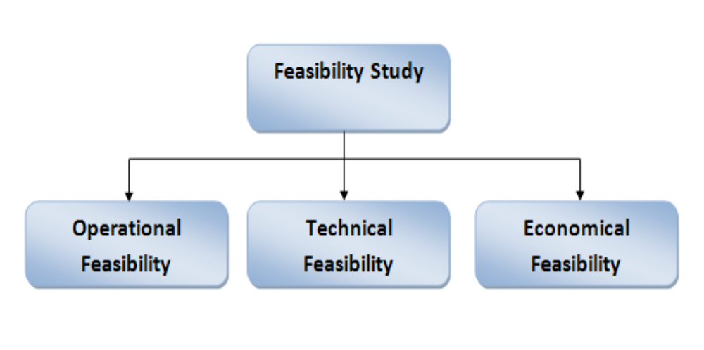

Chapter-3
Design
System Flow Chart:
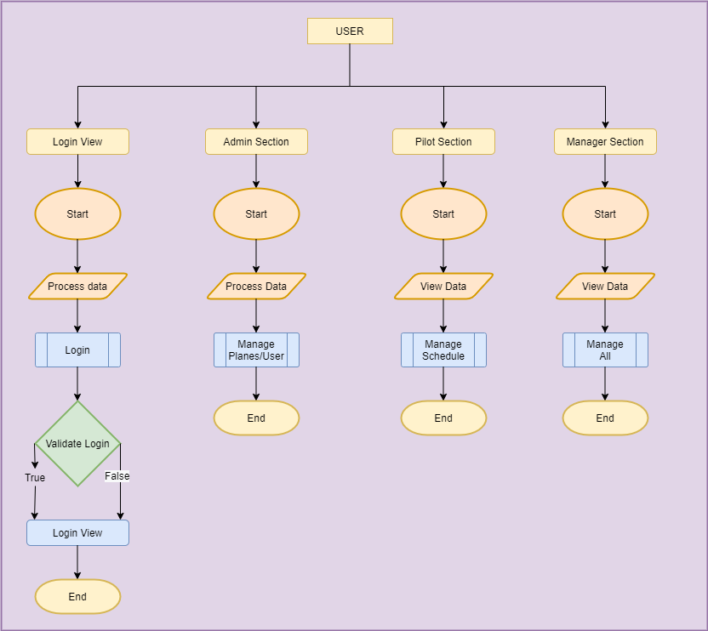

Data dictionary
Data validation:
Procedures are designed to detect errors in data at a lower level of detail. Data validations have been integrated in the system in almost every area where there is a possibility for the user to commit errors. The system will not recognize invalid data.
Whenever an invalid data is keyed in, the system immediately prompts the user and the user has to again key in the data and the system will accept the data only if the data is correct. Validations have been integrated where necessary.
The system is designed to be a user friendly one. In other words the system has been designed to communicate effectively with the user. The system has been designed with pop up menus.

Different Type Of validation:
- Data type validation;
- Range and constraint validation;
- Code and Cross-reference validation; and
Structured validation

Coding

DTO:
UserDTO:
package com.abc.airport.mgt.dto;

import java.util.Date;
import java.util.Set;

import javax.persistence.CascadeType;
import javax.persistence.Column;
import javax.persistence.Entity;
import javax.persistence.FetchType;
import javax.persistence.OneToMany;
import javax.persistence.Table;
import javax.persistence.Transient;

import lombok.Getter;
import lombok.Setter;

@Setter
@Getter
@Entity
@Table(name = "user")
public class UserDTO extends BaseDTO {

@Column(name = "first_name", length = 255)
private String firstName;
@Column(name = "last_name", length = 255)
private String lastName;
@Column(name = "dob", length = 255)
private Date dob;
@Column(name = "gender", length = 255)
private String gender;
@Column(name = "contactNo", length = 255)
private String contactNo;
@Column(name = "login", length = 255)
private String login;
@Column(name = "password", length = 255)
private String password;
@Column(name = "role_id", length = 255)
private long roleId;
@Column(name = "designation", length = 255)
private String designation;
@Column(name = "secret_ans1", length = 455)
private String secretAns1;
@Column(name = "secret_ans2", length = 455)
private String secretAns2;
@Column(name = "secret_ans3", length = 455)
private String secretAns3;
@Column(name = "status", length = 200)
private String status;
@Column(name = "employee_id", length = 20)
private String employeeId;
@Transient
private String confirmPassword;
@Column(name = "ROLE_NAME",length = 225)
private String roleName;

@OneToMany(cascade = CascadeType.ALL, mappedBy = "manager")
private Set<AllotHangerDTO> allots;

/* @OneToMany(cascade = CascadeType.ALL, mappedBy = "pilotId") private
* Set<FlightPlanDTO> updateFlightPlan;
*/

@Override
public String getKey() {
// TODO Auto-generated method stub
return String.valueOf(id);
}

@Override
public String getValue() {
// TODO Auto-generated method stub
return firstName + lastName;
}

}
AddHangerDTO
package com.abc.airport.mgt.dto;

import java.util.Set;

import javax.persistence.CascadeType;
import javax.persistence.Column;
import javax.persistence.Entity;
import javax.persistence.OneToMany;
import javax.persistence.Table;

import lombok.Getter;
import lombok.Setter;

@Setter
@Getter
@Entity
@Table(name = "hanger")
public class AddHangerDTO extends BaseDTO{
@Column(name = "hanger_name", length = 245)
private String hangerName;
@Column(name = "hanger_model",length = 255)
private String hangerModel;
@Column(name = "hanger_address",length = 455)
private String hangerAddress;
@OneToMany(cascade = CascadeType.ALL,mappedBy = "hanger")
private Set<AllotHangerDTO> allots;

@OneToMany(cascade = CascadeType.ALL,mappedBy = "hanger")
private Set<PostFlightModeDTO> postFlight;

@Override
public String getKey() {
// TODO Auto-generated method stub
return id+ "";
}

@Override
public String getValue() {
// TODO Auto-generated method stub
return hangerName;
}

}
PlaneDTO
package com.abc.airport.mgt.dto;

import java.util.Date;
import java.util.Set;

import javax.persistence.CascadeType;
import javax.persistence.Column;
import javax.persistence.Entity;
import javax.persistence.JoinColumn;
import javax.persistence.ManyToOne;
import javax.persistence.OneToMany;
import javax.persistence.Table;

import lombok.Getter;
import lombok.Setter;

@Setter
@Getter
@Entity
@Table(name = "plane")
public class PlaneDTO extends BaseDTO{

@Column(name = "model_number", length = 255)
private String modelNumber;
@Column(name = "purchase_date")
private String purchaseDate;
@Column(name = "last_service_date")
private String lastServiceDate;
@Column(name = "price")
private long price;
@OneToMany(cascade = CascadeType.ALL,mappedBy = "plane")
private Set<UpdateFlightPlanDTO> flightPlanUpdate;

@OneToMany(cascade = CascadeType.ALL,mappedBy = "plane") private
Set<AllotHangerDTO> allots;

@OneToMany(cascade = CascadeType.ALL,mappedBy = "plane")
private Set<PreFlightModeDTO> preFlight;

@Override
public String getKey() {
// TODO Auto-generated method stub
return String.valueOf(id);
}

@Override
public String getValue() {
// TODO Auto-generated method stub
return modelNumber;
}

}
PreFlightModeDTO
package com.abc.airport.mgt.dto;

import java.util.Set;

import javax.persistence.CascadeType;
import javax.persistence.Entity;
import javax.persistence.JoinColumn;
import javax.persistence.ManyToOne;
import javax.persistence.OneToMany;
import javax.persistence.Table;

import lombok.Getter;
import lombok.Setter;

@Setter
@Getter
@Entity
@Table(name = "pre_flight")
public class PreFlightModeDTO extends BaseDTO {

@ManyToOne(cascade = CascadeType.ALL)
@JoinColumn(name = "plane", nullable = false)
private PlaneDTO plane;
private long planeId;

private String laptopPower;

private String laptopBattery;

private String missionPlanner;

private String Motor;
@Override
public String getKey() {
// TODO Auto-generated method stub
return id+ "";
}

@Override
public String getValue() {
// TODO Auto-generated method stub
return laptopPower;
}

}
PostFlightModeDTO
package com.abc.airport.mgt.dto;

import javax.persistence.CascadeType;
import javax.persistence.Entity;
import javax.persistence.JoinColumn;
import javax.persistence.ManyToOne;
import javax.persistence.Table;

import lombok.Getter;
import lombok.Setter;

@Setter
@Getter
@Entity
@Table(name = "post_flight")
public class PostFlightModeDTO extends BaseDTO {
@ManyToOne(cascade = CascadeType.ALL)
@JoinColumn(name = "plane", nullable = false)
private PlaneDTO plane;
private long planeId;

private String masterSwitch;

@ManyToOne(cascade = CascadeType.ALL)
@JoinColumn(name = "hanger", nullable = false)
private AddHangerDTO hanger;
private long hangerId;

@Override
public String getKey() {
// TODO Auto-generated method stub
return null;
}

@Override
public String getValue() {
// TODO Auto-generated method stub
return null;
}

}
LoginController
package com.abc.airport.mgt.ctl;

import java.util.Calendar;
import java.util.Date;
import java.util.HashMap;
import java.util.List;
import java.util.logging.Logger;

import javax.servlet.http.HttpServletRequest;
import javax.servlet.http.HttpSession;
import javax.validation.Valid;

import org.springframework.beans.factory.annotation.Autowired;
import org.springframework.stereotype.Controller;
import org.springframework.ui.Model;
import org.springframework.validation.BindingResult;
import org.springframework.web.bind.annotation.GetMapping;
import org.springframework.web.bind.annotation.ModelAttribute;
import org.springframework.web.bind.annotation.PostMapping;
import org.springframework.web.bind.annotation.RequestMapping;
import org.springframework.web.bind.annotation.RequestMethod;
import org.springframework.web.bind.annotation.RequestParam;

import com.abc.airport.mgt.dto.UserDTO;
import com.abc.airport.mgt.exception.DuplicateRecordException;
import com.abc.airport.mgt.form.ChangePasswordForm;
import com.abc.airport.mgt.form.ForgetPasswordForm;
import com.abc.airport.mgt.form.LoginForm;
import com.abc.airport.mgt.form.ManagerForm;
import com.abc.airport.mgt.form.PilotForm;
import com.abc.airport.mgt.form.UserRegistrationForm;
import com.abc.airport.mgt.service.UserServiceInt;
import com.abc.airport.mgt.util.DataUtility;

@Controller
public class LoginCtl extends BaseCtl {

private Logger log = Logger.getLogger(LoginCtl.class.getName());

protected static final String OP_SIGNIN = "SignIn";
protected static final String OP_SIGNUP = "SignUp";
protected static final String OP_LOGOUT = "Logout";

@Autowired
private UserServiceInt userServiceInt;

@GetMapping("/home/signUp")
public String display(@ModelAttribute("form") UserRegistrationForm form, Model model) {
log.info("LoginCtl signUp display method start");
log.info("LoginCtl signUp display method End");
return "signUp";
}

@ModelAttribute
public void preload(Model model) {

HashMap<String, String> map2 = new HashMap<String, String>();
map2.put("Male", "Male");
map2.put("Female", "Female");
model.addAttribute("gender", map2);

HashMap<String, String> map3 = new HashMap<String, String>();
map3.put("Pilot", "Pilot");
map3.put("Manager", "Manager");
model.addAttribute("designation", map3);

HashMap<String, String> map4 = new HashMap<String, String>();
map4.put("Accept", "Accept");
map4.put("Reject", "Reject");
model.addAttribute("statusApproval", map4);

}

@PostMapping("/home/signUp")
public String submit(@RequestParam String operation, @Valid @ModelAttribute("form") UserRegistrationForm form,
BindingResult bindingResult, Model model, HttpServletRequest request) {

log.info("LoginCtl signUp submit method start");

if (OP_RESET.equalsIgnoreCase(form.getOperation())) {
return "redirect:/home/signUp";
}

if (bindingResult.hasErrors()) {
System.out.println(bindingResult);
return "signUp";
}

try {
if (OP_SAVE.equalsIgnoreCase(form.getOperation())) {
UserDTO entity = (UserDTO) populateDTO(form.getDTO(), request);

int dob = entity.getDob().getYear()+1900; System.out.println("dob "+dob);

int current = Calendar.getInstance().get(Calendar.YEAR);
System.out.println("current "+current); int age = current - dob;
System.out.println("age "+age);
if(age < 17) {
model.addAttribute("ageError",
"Age cannot be less than 17.");
return "signUp";
}

System.out.println(entity.toString());
if(entity.getDesignation().equalsIgnoreCase("Pilot")) {
entity.setRoleId(3L); //for pilot 3
}
else
{
entity.setRoleId(2L); // for manager 2
}

userServiceInt.add(entity);
model.addAttribute("success", "User Registerd Successfully!!!!");
model.addAttribute("empId", " Your Employee Id is "+ "ID-"+entity.getEmployeeId());
return "signUp";
}
} catch (DuplicateRecordException e) {
model.addAttribute("error", e.getMessage());
return "signUp";
}

log.info("LoginCtl signUp submit method end");
return "signUp";
}

@GetMapping("/home/login")
public String display(@ModelAttribute("form") LoginForm form,
HttpSession session, Model model) {
log.info("LoginCtl login display method start");
if (session.getAttribute("user") != null) {
session.invalidate();
model.addAttribute("success", "You have logout Successfully!!!");
}

log.info("LoginCtl login display method End");
return "login";
}
@PostMapping("/home/login")
public String submit(@RequestParam String operation, HttpSession session,
@Valid @ModelAttribute("form") LoginForm form, BindingResult result, Model model) {
log.info("LoginCtl login submit method start");
System.out.println("In dopost LoginCtl");

if (OP_SIGNUP.equalsIgnoreCase(form.getOperation())) {
return "redirect:/home/login";
}

if (result.hasErrors()) {
System.out.println(result);
return "login";
}

UserDTO bean = userServiceInt.authentication((UserDTO) form.getDTO());

if (bean != null) {
if(bean.getStatus().equalsIgnoreCase("0")) {
model.addAttribute("msg", "Wait for Admin to accept");
return "redirect:/home";
}
System.out.println(bean.toString());
session.setAttribute("user", bean);
return "redirect:/home";
}
// System.out.println("status "+bean.getStatus());

if(bean==null) {

model.addAttribute("error", "Employee Id & Password Invalid");}
log.info("LoginCtl login submit method End");
return "login";
}

@RequestMapping(value = "/home/login/forgetPassword", method = RequestMethod.GET)
public String display(@ModelAttribute("form") ForgetPasswordForm form, HttpSession session, Model model) {

System.out.println("In doget LoginCtl forgetpassword");

return "forgetPassword";

}

@RequestMapping(value = "/home/login/forgetPassword", method = RequestMethod.POST)
public String display(@ModelAttribute("form") @Valid ForgetPasswordForm form, BindingResult bindingResult,
Model model, HttpSession session) {

if (bindingResult.hasErrors()) {
return "forgetPassword";
}
System.out.println("***Login******"+form.getLogin());
UserDTO dto = userServiceInt.findByLogin(form.getLogin());
System.out.println("dto"+dto.getLogin());

if (dto == null) {
model.addAttribute("error", "Invalid Input Entered");
return "forgetPassword";
}

if (dto != null) {
UserDTO u=userServiceInt.findByAll(form.getEmployeeId(),form.getLogin(),form.getSecretAns1(),form.getSecretAns2(),form.getSecretAns3());
//model.addAttribute("success", "Password has been sent to your registered Email ID!!");
if(!DataUtility.getStringData(dto.getLogin()).equalsIgnoreCase(form.getLogin()) ) {
model.addAttribute("error", "Incorrect details matched");
return "forgetPassword";
}
session.setAttribute("id", form.getEmployeeId());
System.out.println("****error*****"+form.getEmployeeId());
model.addAttribute("success", "Password is Sent to Email id");
}
return "forgetPassword";
}

@RequestMapping(value = "/home/login/changepassword", method = RequestMethod.GET)
public String displayChangePassword(@ModelAttribute("form") ChangePasswordForm form, HttpSession session, Model model) {

return "changePassword";

}

@RequestMapping(value = "/home/login/changepassword", method = RequestMethod.POST)
public String submitChangePassword(HttpSession session, @ModelAttribute("form") @Valid ChangePasswordForm form,
BindingResult bindingResult, Model model) {

if (bindingResult.hasErrors()) {
System.out.println("erro"+bindingResult.getAllErrors());
return "changePassword";
}
if (form.getNewPassword().equalsIgnoreCase(form.getConfirmPassword())) {

UserDTO dto = (UserDTO) session.getAttribute("user");
dto = userServiceInt.findBypk(dto.getId());

if (userServiceInt.changePassword(dto.getId(), form.getOldPassword(), form.getNewPassword())) {
model.addAttribute("success", "Password changed Successfully");
} else {
model.addAttribute("error", "Old Passowors Does not Matched");
}
} else {
model.addAttribute("error", "New Password and confirm password does not matched");
}
return "changePassword";
}
@RequestMapping(value = "/home/login/manager/search", method = { RequestMethod.GET, RequestMethod.POST })
public String searchList(@ModelAttribute("form") ManagerForm form,
@RequestParam(required = false) String operation, Long vid, HttpSession session, Model model) {

if (OP_RESET.equalsIgnoreCase(operation)) {
return "redirect:/home/login/manager/search";
}

int pageNo = form.getPageNo();
int pageSize = form.getPageSize();

if (OP_NEXT.equals(operation)) {
pageNo++;
} else if (OP_PREVIOUS.equals(operation)) {
pageNo--;
} else if (OP_NEW.equals(operation)) {
return "redirect:/home/login/manager";
}

pageNo = (pageNo < 1) ? 1 : pageNo;
pageSize = (pageSize < 1) ? 10 : pageSize;

if (OP_DELETE.equals(operation)) {
pageNo = 1;
if (form.getIds() != null) {
for (long id : form.getIds()) {
UserDTO dto = new UserDTO();
dto.setId(id);
userServiceInt.delete(dto);
}
model.addAttribute("success", "Deleted Successfully!!!");
} else {
model.addAttribute("error", "Select at least one record");
}
}
UserDTO dto = (UserDTO) form.getDTO();

UserDTO uDto = (UserDTO) session.getAttribute("user");

dto.setRoleId(2L);
List<UserDTO> list = userServiceInt.search(dto, pageNo, pageSize);
List<UserDTO> totallist = userServiceInt.search(dto);
model.addAttribute("list", list);

if (list.size() == 0 && !OP_DELETE.equalsIgnoreCase(operation)) {
model.addAttribute("error", "Record not found");
}

int listsize = list.size();
int total = totallist.size();
int pageNoPageSize = pageNo * pageSize;

form.setPageNo(pageNo);
form.setPageSize(pageSize);
model.addAttribute("pageNo", pageNo);
model.addAttribute("pageSize", pageSize);
model.addAttribute("listsize", listsize);
model.addAttribute("total", total);
model.addAttribute("pagenosize", pageNoPageSize);
model.addAttribute("form", form);
return "userList";
}

//Edit Page show
@GetMapping("/home/login/manager")
public String display(@RequestParam(required = false) Long id, Long pId, @ModelAttribute("form") ManagerForm form,
HttpSession session, Model model) {
if (form.getId() > 0) {
UserDTO bean = userServiceInt.findBypk(id);
form.populate(bean);
}
return "approvePage";
}
//accept or reject manager
@PostMapping("/home/login/manager")
public String submit(@Valid @ModelAttribute("form") ManagerForm form, BindingResult bindingResult,
HttpSession session, Model model,HttpServletRequest request) {

if (OP_RESET.equalsIgnoreCase(form.getOperation())) {
return "redirect:/home/login/manager";
}

try {
if (OP_SAVE.equalsIgnoreCase(form.getOperation())) {

if (bindingResult.hasErrors()) {
return "approvePage";
}
UserDTO bean = (UserDTO) populateDTO(form.getDTO(),request);
bean.setRoleId(2L);
bean.setRoleName("MANAGER");
System.out.println("formmm" + form.getStatusApproval());
System.out.println("Id "+bean.getId());
if(form.getStatusApproval().equalsIgnoreCase("Accept")) {
bean.setStatus("1");}
else if(form.getStatusApproval().equalsIgnoreCase("Reject")) {
System.out.println("******"+bean.getStatus());
bean.setStatus("0");
}
if (bean.getId() > 0) {
userServiceInt.update(bean);
if(bean.getStatus().equalsIgnoreCase("1")) {
model.addAttribute("success", "Manager is Approved!!!!");}
else {
model.addAttribute("success", "Manager is Rejected!!!!");
}

} else {
userServiceInt.add(bean);
model.addAttribute("success", "Manager Added Successfully!!!!");
}
return "approvePage";
}
} catch (DuplicateRecordException e) {
model.addAttribute("error", e.getMessage());
return "approvePage";
}
return "";
}

////////////////////////
@RequestMapping(value = "/home/login/pilot/search", method = { RequestMethod.GET, RequestMethod.POST })
public String searchList(@ModelAttribute("form") PilotForm form,
@RequestParam(required = false) String operation, Long vid, HttpSession session, Model model) {

System.out.println("id id "+form.getId());
if (OP_RESET.equalsIgnoreCase(operation)) {
return "redirect:/home/login/pilot/search";
}

int pageNo = form.getPageNo();
int pageSize = form.getPageSize();

if (OP_NEXT.equals(operation)) {
pageNo++;
} else if (OP_PREVIOUS.equals(operation)) {
pageNo--;
} else if (OP_NEW.equals(operation)) {
return "redirect:/home/login/pilot";
}

pageNo = (pageNo < 1) ? 1 : pageNo;
pageSize = (pageSize < 1) ? 10 : pageSize;

if (OP_DELETE.equals(operation)) {
pageNo = 1;
if (form.getIds() != null) {
for (long id : form.getIds()) {
UserDTO dto = new UserDTO();
dto.setId(id);
System.out.println("id is "+id);
userServiceInt.delete(dto);
}
model.addAttribute("success", "Deleted Successfully!!!");
} else {
model.addAttribute("error", "Select at least one record");
}
}
UserDTO dto = (UserDTO) form.getDTO();

UserDTO uDto = (UserDTO) session.getAttribute("user");

dto.setRoleId(3L);
List<UserDTO> list = userServiceInt.search(dto, pageNo, pageSize);
List<UserDTO> totallist = userServiceInt.search(dto);
model.addAttribute("list", list);

if (list.size() == 0 && !OP_DELETE.equalsIgnoreCase(operation)) {
model.addAttribute("error", "Record not found");
}

int listsize = list.size();
int total = totallist.size();
int pageNoPageSize = pageNo * pageSize;

form.setPageNo(pageNo);
form.setPageSize(pageSize);
model.addAttribute("pageNo", pageNo);
model.addAttribute("pageSize", pageSize);
model.addAttribute("listsize", listsize);
model.addAttribute("total", total);
model.addAttribute("pagenosize", pageNoPageSize);
model.addAttribute("form", form);
return "pilotList";
}

//Edit Page show
@GetMapping("/home/login/pilot")
public String display(@RequestParam(required = false) Long id, Long pId, @ModelAttribute("form") PilotForm form,
HttpSession session, Model model) {
if (form.getId() > 0) {
UserDTO bean = userServiceInt.findBypk(id);
System.out.println("name"+bean.getFirstName());
System.out.println("password"+bean.getPassword());
form.populate(bean);
}
return "approvePilot";
}
//accept or reject pilot
@PostMapping("/home/login/pilot")
public String submit(@Valid @ModelAttribute("form") PilotForm form, BindingResult bindingResult,
HttpSession session, Model model,HttpServletRequest request) {
System.out.println("inside pilot");
if (OP_RESET.equalsIgnoreCase(form.getOperation())) {
return "redirect:/home/login/pilot";
}

try {
if (OP_SAVE.equalsIgnoreCase(form.getOperation())) {
System.out.println("hello");
if (bindingResult.hasErrors()) {
System.out.println("aa");
System.out.println("****error****"+bindingResult.getAllErrors());
return "approvePilot";
}
UserDTO bean = (UserDTO) populateDTO(form.getDTO(),request);
System.out.println("beannnn"+bean.getPassword());
UserDTO uDto=userServiceInt.findBypk(bean.getId());
System.out.println("a");
bean.setRoleId(3L);
bean.setRoleName("PILOT");
System.out.println("formmm" + form.getStatusApproval());
System.out.println("Id "+bean.getId());
if(form.getStatusApproval().equalsIgnoreCase("Accept")) {
bean.setStatus("1");}
else if(form.getStatusApproval().equalsIgnoreCase("Reject")) {
System.out.println("******"+bean.getStatus());
bean.setStatus("0");
}
/*
* bean.setEmployeeId(bean.getEmployeeId());
* bean.setPassword(bean.getPassword());
* bean.setSecretAns1(bean.getSecretAns1());
* bean.setSecretAns2(bean.getSecretAns2());
* bean.setSecretAns3(bean.getSecretAns3());
*/

if (bean.getId() > 0) {

userServiceInt.update(bean);
if(bean.getStatus().equalsIgnoreCase("1")) {
model.addAttribute("success", "Pilot is Approved!!!!");}
else {
model.addAttribute("success", "Pilot is Rejected!!!!");
}
} else {
userServiceInt.add(bean);
model.addAttribute("success", "Pilot Added Successfully!!!!");
}
return "approvePilot";
}
} catch (DuplicateRecordException e) {
model.addAttribute("error", e.getMessage());
return "approvePilot";
}
return "";
}
}
AddHangerCtl
package com.abc.airport.mgt.ctl;

import java.util.List;

import javax.servlet.http.HttpServletRequest;
import javax.servlet.http.HttpSession;
import javax.validation.Valid;

import org.springframework.beans.factory.annotation.Autowired;
import org.springframework.stereotype.Controller;
import org.springframework.ui.Model;
import org.springframework.validation.BindingResult;
import org.springframework.web.bind.annotation.GetMapping;
import org.springframework.web.bind.annotation.ModelAttribute;
import org.springframework.web.bind.annotation.PostMapping;
import org.springframework.web.bind.annotation.RequestMapping;
import org.springframework.web.bind.annotation.RequestMethod;
import org.springframework.web.bind.annotation.RequestParam;

import com.abc.airport.mgt.dto.AddHangerDTO;
import com.abc.airport.mgt.exception.DuplicateRecordException;
import com.abc.airport.mgt.form.AddHangerForm;
import com.abc.airport.mgt.service.AddHangerServiceInt;

@Controller
public class AddHangerCtl extends BaseCtl{

@Autowired
private AddHangerServiceInt service;

@GetMapping("/home/login/hanger")
public String display(@RequestParam(required = false) Long id, Long pId, @ModelAttribute("form") AddHangerForm form,
HttpSession session, Model model) {
if (form.getId() > 0) {
AddHangerDTO bean = service.findBypk(id);
form.populate(bean);
}
return "addHanger";
}

@PostMapping("/home/login/hanger")
public String submit(@Valid @ModelAttribute("form") AddHangerForm form, BindingResult bindingResult,
HttpSession session, Model model,HttpServletRequest request) {

if (OP_RESET.equalsIgnoreCase(form.getOperation())) {
return "redirect:/home/login/hanger";
}

try {
if (OP_SAVE.equalsIgnoreCase(form.getOperation())) {

if (bindingResult.hasErrors()) {
return "addHanger";
}
AddHangerDTO bean = (AddHangerDTO) populateDTO(form.getDTO(),request);
if (bean.getId() > 0) {
service.update(bean);
model.addAttribute("success", "Hanger update Successfully!!!!");
} else {
service.add(bean);
model.addAttribute("success", "Hanger Added Successfully!!!!");
}
return "addHanger";
}
} catch (DuplicateRecordException e) {
model.addAttribute("error", e.getMessage());
return "addHanger";
}
return "";
}

@RequestMapping(value = "/home/login/hanger/search", method = { RequestMethod.GET, RequestMethod.POST })
public String searchList(@ModelAttribute("form") AddHangerForm form,
@RequestParam(required = false) String operation, Long vid, HttpSession session, Model model) {

if (OP_RESET.equalsIgnoreCase(operation)) {
return "redirect:/home/login/hanger/search";
}

int pageNo = form.getPageNo();
int pageSize = form.getPageSize();

if (OP_NEXT.equals(operation)) {
pageNo++;
} else if (OP_PREVIOUS.equals(operation)) {
pageNo--;
} else if (OP_NEW.equals(operation)) {
return "redirect:/home/login/hanger";
}

pageNo = (pageNo < 1) ? 1 : pageNo;
pageSize = (pageSize < 1) ? 10 : pageSize;

if (OP_DELETE.equals(operation)) {
pageNo = 1;
if (form.getIds() != null) {
for (long id : form.getIds()) {
AddHangerDTO dto = new AddHangerDTO();
dto.setId(id);
service.delete(dto);
}
model.addAttribute("success", "Deleted Successfully!!!");
} else {
model.addAttribute("error", "Select at least one record");
}
}
AddHangerDTO dto = (AddHangerDTO) form.getDTO();

AddHangerDTO uDto = (AddHangerDTO) session.getAttribute("Hanger");

List<AddHangerDTO> list = service.search(dto, pageNo, pageSize);
List<AddHangerDTO> totallist = service.search(dto);
model.addAttribute("list", list);

if (list.size() == 0 && !OP_DELETE.equalsIgnoreCase(operation)) {
model.addAttribute("error", "Record not found");
}

int listsize = list.size();
int total = totallist.size();
int pageNoPageSize = pageNo * pageSize;

form.setPageNo(pageNo);
form.setPageSize(pageSize);
model.addAttribute("pageNo", pageNo);
model.addAttribute("pageSize", pageSize);
model.addAttribute("listsize", listsize);
model.addAttribute("total", total);
model.addAttribute("pagenosize", pageNoPageSize);
model.addAttribute("form", form);
return "hangerList";
}

}
PreFlightModeCtl

package com.abc.airport.mgt.ctl;

import java.util.HashMap;
import java.util.List;

import javax.servlet.http.HttpServletRequest;
import javax.servlet.http.HttpSession;
import javax.validation.Valid;

import org.springframework.beans.factory.annotation.Autowired;
import org.springframework.stereotype.Controller;
import org.springframework.ui.Model;
import org.springframework.validation.BindingResult;
import org.springframework.web.bind.annotation.GetMapping;
import org.springframework.web.bind.annotation.ModelAttribute;
import org.springframework.web.bind.annotation.PostMapping;
import org.springframework.web.bind.annotation.RequestMapping;
import org.springframework.web.bind.annotation.RequestMethod;
import org.springframework.web.bind.annotation.RequestParam;

import com.abc.airport.mgt.dto.PlaneDTO;
import com.abc.airport.mgt.dto.PreFlightModeDTO;
import com.abc.airport.mgt.dto.UserDTO;
import com.abc.airport.mgt.exception.DuplicateRecordException;
import com.abc.airport.mgt.form.PlaneForm;
import com.abc.airport.mgt.form.PreFlightModeForm;
import com.abc.airport.mgt.service.PlaneServiceInt;
import com.abc.airport.mgt.service.PreFlightModeServiceInt;

@Controller
public class PreFlightModeCtl extends BaseCtl{

@Autowired
private PlaneServiceInt planeServiceInt;
@Autowired
private PreFlightModeServiceInt preServiceInt;

@ModelAttribute
public void preload(Model model) {
HashMap<String, String> map2 = new HashMap<String, String>();
map2.put("ON", "ON");
map2.put("OFF", "OFF");
model.addAttribute("laptop_power", map2);

HashMap<String, String> map3 = new HashMap<String, String>();
map3.put("Full Charged", "Full Charged");
map3.put("less than 50%", "less than 50%");
model.addAttribute("laptop_battery", map3);

HashMap<String, String> map4 = new HashMap<String, String>();
map4.put("Start", "Start");
map4.put("Stop", "Stop");
model.addAttribute("mission", map4);

HashMap<String, String> map5 = new HashMap<String, String>();
map5.put("Secured", "Secured");
map5.put("Damaged", "Damaged");
model.addAttribute("motor", map5);

UserDTO uDto=new UserDTO();
uDto.setRoleId(3L);
// model.addAttribute("pilotList",userService.search(uDto));
model.addAttribute("planeList",planeServiceInt.search(null));
//model.addAttribute("deslocList",desService.search(null));

}

@GetMapping("/home/login/flightlist")
public String display(@RequestParam(required = false) Long id, Long pId, @ModelAttribute("form") PreFlightModeForm form,
HttpSession session, Model model) {
System.out.println("****form*****"+form.getId());
if (form.getId() > 0) {
PreFlightModeDTO bean = preServiceInt.findBypk(id);
form.populate(bean);
}
return "updatePreFlightCheckList";
}

@RequestMapping(value = "/home/login/flightlist/search", method = { RequestMethod.GET, RequestMethod.POST })
public String searchList(@ModelAttribute("form") PreFlightModeForm form,
@RequestParam(required = false) String operation, Long vid, HttpSession session, Model model) {

if (OP_RESET.equalsIgnoreCase(operation)) {
return "redirect:/home/login/flightlist/search";
}

int pageNo = form.getPageNo();
int pageSize = form.getPageSize();

if (OP_NEXT.equals(operation)) {
pageNo++;
} else if (OP_PREVIOUS.equals(operation)) {
pageNo--;
} else if (OP_NEW.equals(operation)) {
return "redirect:/home/login/plane";
}

pageNo = (pageNo < 1) ? 1 : pageNo;
pageSize = (pageSize < 1) ? 10 : pageSize;

if (OP_DELETE.equals(operation)) {
pageNo = 1;
if (form.getIds() != null) {
for (long id : form.getIds()) {
PlaneDTO dto = new PlaneDTO();
dto.setId(id);
planeServiceInt.delete(dto);
}
model.addAttribute("success", "Deleted Successfully!!!");
} else {
model.addAttribute("error", "Select at least one record");
}
}
PreFlightModeDTO dto = (PreFlightModeDTO) form.getDTO();

//PlaneDTO uDto = (PlaneDTO) session.getAttribute("Plane");

List<PreFlightModeDTO> list = preServiceInt.search(dto, pageNo, pageSize);
List<PreFlightModeDTO> totallist = preServiceInt.search(dto);
model.addAttribute("list", list);

if (list.size() == 0 && !OP_DELETE.equalsIgnoreCase(operation)) {
model.addAttribute("error", "Record not found");
}

int listsize = list.size();
int total = totallist.size();
int pageNoPageSize = pageNo * pageSize;

form.setPageNo(pageNo);
form.setPageSize(pageSize);
model.addAttribute("pageNo", pageNo);
model.addAttribute("pageSize", pageSize);
model.addAttribute("listsize", listsize);
model.addAttribute("total", total);
model.addAttribute("pagenosize", pageNoPageSize);
model.addAttribute("form", form);
return "viewPreFlightModeList";
}

@PostMapping("/home/login/flightlist")
public String submit(@Valid @ModelAttribute("form") PreFlightModeForm form, BindingResult bindingResult,
HttpSession session, Model model,HttpServletRequest request) {

if (OP_RESET.equalsIgnoreCase(form.getOperation())) {
return "redirect:/home/login/flightlist";
}

try {
if (OP_SAVE.equalsIgnoreCase(form.getOperation())) {

if (bindingResult.hasErrors()) {
return "updatePreFlightCheckList";
}
PreFlightModeDTO bean = (PreFlightModeDTO) populateDTO(form.getDTO(),request);
bean.setPlane(planeServiceInt.findBypk(bean.getPlaneId()));
System.out.println("****id*********"+bean.getId());
if (bean.getId() > 0) {
preServiceInt.update(bean);
model.addAttribute("success", "Check List update Successfully!!!!");
} else {
preServiceInt.add(bean);
model.addAttribute("success", "Check list Added Successfully!!!!");
}
return "updatePreFlightCheckList";
}
} catch (DuplicateRecordException e) {
model.addAttribute("error", e.getMessage());
return "updatePreFlightCheckList";
}
return "";
}
}
PostFlightModeCtl

package com.abc.airport.mgt.ctl;

import java.util.HashMap;
import java.util.List;

import javax.servlet.http.HttpServletRequest;
import javax.servlet.http.HttpSession;
import javax.validation.Valid;

import org.springframework.beans.factory.annotation.Autowired;
import org.springframework.stereotype.Controller;
import org.springframework.ui.Model;
import org.springframework.validation.BindingResult;
import org.springframework.web.bind.annotation.GetMapping;
import org.springframework.web.bind.annotation.ModelAttribute;
import org.springframework.web.bind.annotation.PostMapping;
import org.springframework.web.bind.annotation.RequestMapping;
import org.springframework.web.bind.annotation.RequestMethod;
import org.springframework.web.bind.annotation.RequestParam;

import com.abc.airport.mgt.dto.AddHangerDTO;
import com.abc.airport.mgt.dto.PlaneDTO;
import com.abc.airport.mgt.dto.PostFlightModeDTO;
import com.abc.airport.mgt.dto.PreFlightModeDTO;
import com.abc.airport.mgt.dto.UserDTO;
import com.abc.airport.mgt.exception.DuplicateRecordException;
import com.abc.airport.mgt.form.PostFlightModeForm;

import com.abc.airport.mgt.service.AddHangerServiceInt;
import com.abc.airport.mgt.service.PlaneServiceInt;
import com.abc.airport.mgt.service.PostFlightModeServiceInt;
import com.abc.airport.mgt.service.PreFlightModeServiceInt;

@Controller
public class PostFlightModeCtl extends BaseCtl {

@Autowired
private PlaneServiceInt planeServiceInt;
@Autowired
private PostFlightModeServiceInt postServiceInt;
@Autowired
private AddHangerServiceInt hangerService;
@ModelAttribute
public void preload(Model model) {
HashMap<String, String> map2 = new HashMap<String, String>();
map2.put("ON", "ON");
map2.put("OFF", "OFF");
model.addAttribute("masterSwitch", map2);

UserDTO uDto=new UserDTO();
uDto.setRoleId(3L);
// model.addAttribute("pilotList",userService.search(uDto));
model.addAttribute("planeList",planeServiceInt.search(null));
model.addAttribute("hangerList",hangerService.search(null));

}

@GetMapping("/home/login/postflightlist")
public String display(@RequestParam(required = false) Long id, Long pId, @ModelAttribute("form") PostFlightModeForm form,
HttpSession session, Model model) {
System.out.println("****form*****"+form.getId());
if (form.getId() > 0) {
PostFlightModeDTO bean = postServiceInt.findBypk(id);
form.populate(bean);
}
return "updatePostFlightCheckList";
}

@RequestMapping(value = "/home/login/postflightlist/search", method = { RequestMethod.GET, RequestMethod.POST })
public String searchList(@ModelAttribute("form") PostFlightModeForm form,
@RequestParam(required = false) String operation, Long vid, HttpSession session, Model model) {

if (OP_RESET.equalsIgnoreCase(operation)) {
return "redirect:/home/login/postflightlist/search";
}

int pageNo = form.getPageNo();
int pageSize = form.getPageSize();

if (OP_NEXT.equals(operation)) {
pageNo++;
} else if (OP_PREVIOUS.equals(operation)) {
pageNo--;
} else if (OP_NEW.equals(operation)) {
return "redirect:/home/login/plane";
}

pageNo = (pageNo < 1) ? 1 : pageNo;
pageSize = (pageSize < 1) ? 10 : pageSize;

if (OP_DELETE.equals(operation)) {
pageNo = 1;
if (form.getIds() != null) {
for (long id : form.getIds()) {
PlaneDTO dto = new PlaneDTO();
dto.setId(id);
planeServiceInt.delete(dto);
}
model.addAttribute("success", "Deleted Successfully!!!");
} else {
model.addAttribute("error", "Select at least one record");
}
}
PostFlightModeDTO dto = (PostFlightModeDTO) form.getDTO();

//PlaneDTO uDto = (PlaneDTO) session.getAttribute("Plane");

List<PostFlightModeDTO> list = postServiceInt.search(dto, pageNo, pageSize);
List<PostFlightModeDTO> totallist = postServiceInt.search(dto);
model.addAttribute("list", list);

if (list.size() == 0 && !OP_DELETE.equalsIgnoreCase(operation)) {
model.addAttribute("error", "Record not found");
}

int listsize = list.size();
int total = totallist.size();
int pageNoPageSize = pageNo * pageSize;

form.setPageNo(pageNo);
form.setPageSize(pageSize);
model.addAttribute("pageNo", pageNo);
model.addAttribute("pageSize", pageSize);
model.addAttribute("listsize", listsize);
model.addAttribute("total", total);
model.addAttribute("pagenosize", pageNoPageSize);
model.addAttribute("form", form);
return "viewPostFlightModeList";
}

@PostMapping("/home/login/postflightlist")
public String submit(@Valid @ModelAttribute("form") PostFlightModeForm form, BindingResult bindingResult,
HttpSession session, Model model,HttpServletRequest request) {

if (OP_RESET.equalsIgnoreCase(form.getOperation())) {
return "redirect:/home/login/postflightlist";
}

try {
if (OP_SAVE.equalsIgnoreCase(form.getOperation())) {

if (bindingResult.hasErrors()) {
return "updatePostFlightCheckList";
}
PostFlightModeDTO bean = (PostFlightModeDTO) populateDTO(form.getDTO(),request);
bean.setPlane(planeServiceInt.findBypk(bean.getPlaneId()));
bean.setHanger(hangerService.findBypk(bean.getHangerId()));
System.out.println("****id*********"+bean.getId());
if (bean.getId() > 0) {
postServiceInt.update(bean);
model.addAttribute("success", "Check List update Successfully!!!!");
} else {
postServiceInt.add(bean);
model.addAttribute("success", "Check list Added Successfully!!!!");
}
return "updatePostFlightCheckList";
}
} catch (DuplicateRecordException e) {
model.addAttribute("error", e.getMessage());
return "updatePostFlightCheckList";
}
return "";
}
}
UserDAOInt

package com.abc.airport.mgt.dao;

import java.util.List;

import com.abc.airport.mgt.dto.UserDTO;

public interface UserDAOInt {

public long add(UserDTO dto);

public void delete(UserDTO dto);

public UserDTO findBypk(long pk);

public UserDTO findByLogin(String login);

public void update(UserDTO dto);

public List<UserDTO> list();

public List<UserDTO>list(int pageNo,int pageSize);

public List<UserDTO> search(UserDTO dto);

public List<UserDTO> search(UserDTO dto,int pageNo,int pageSize);

public UserDTO authentication(UserDTO dto);

String findByMaxEmployeeId();

public UserDTO findAll(String employeeId, String login, String secretAns1, String secretANs2, String secretAns3);

UserDTO findByEmployeeId(String pk);

//UserDTO findByEmployeeId(String pk);
}
UserDAOImpl
package com.abc.airport.mgt.dao;

import java.util.HashSet;
import java.util.List;
import java.util.Random;
import java.util.logging.Logger;

import javax.persistence.EntityManager;
import javax.persistence.NoResultException;

import org.hibernate.Criteria;
import org.hibernate.HibernateException;
import org.hibernate.Session;
import org.hibernate.SessionFactory;
import org.hibernate.criterion.DetachedCriteria;
import org.hibernate.criterion.Projections;
import org.hibernate.criterion.Property;
import org.hibernate.criterion.Restrictions;
import org.hibernate.query.Query;
import org.springframework.beans.factory.annotation.Autowired;
import org.springframework.stereotype.Repository;

import com.abc.airport.mgt.dto.UserDTO;

@Repository
public class UserDAOImpl implements UserDAOInt{

private static Logger log = Logger.getLogger(UserDAOImpl.class.getName());
@Autowired
private EntityManager entityManager;

@Override
public long add(UserDTO dto) {
// TODO Add User
log.info("UserDAOImpl Add method Start");
Session session = entityManager.unwrap(Session.class);
/*
* Random r = new Random(); HashSet<Integer> set = new HashSet<>();
* while(set.size()<1) { int random = r.nextInt(999)+10;//this will store random
* number within the range set.add(random); } for(int randoNum: set) {
* dto.setEmployeeId(String .valueOf(randoNum)); }
*/
Integer eid = Integer.parseInt(findByMaxEmployeeId())+1;
System.out.println("*********"+eid);
// String empId = String.valueOf( eid)+1;
dto.setEmployeeId(String.valueOf(eid));
long pk = (long) session.save(dto);

log.info("UserDAOImpl Add method End");
return pk;
}

@Override
public void delete(UserDTO dto) {
// TODO Delete
log.info("UserDAOImpl Delete method Start");
entityManager.remove(entityManager.contains(dto) ? dto : entityManager.merge(dto));
log.info("UserDAOImpl Delete method End");
}

@Override
public UserDTO findBypk(long pk) {
// TODO find by pk
log.info("UserDAOImpl FindByPk method Start");
Session session = entityManager.unwrap(Session.class);
UserDTO dto = (UserDTO) session.get(UserDTO.class, pk);
//System.out.println("dto "+dto.getPassword());
//System.out.println("dto name "+dto.getFirstName());
log.info("UserDAOImpl FindByPk method End");
return dto;
}
@Override
public UserDTO findByEmployeeId(String employeeId) {
// TODO find by pk
System.out.println("pk is "+employeeId);
log.info("UserDAOImpl FindByPk method Start");
Session session = entityManager.unwrap(Session.class);
Query q = session.createNativeQuery("select * from user where employee_id like '"+employeeId+"'");
//q.setParameter(1, employeeId);
//q.setParameter("employeeId", employeeId);
UserDTO dto = (UserDTO)q.uniqueResult();
//UserDTO dto = (UserDTO) criteria.uniqueResult();
System.out.println("dto "+dto);
System.out.println("dto name "+dto.getFirstName());
log.info("UserDAOImpl FindByPk method End");
return dto;
}

@Override
public UserDTO findByLogin(String login) {
// TODO Auto-generated method stub
log.info("UserDAOImpl FindByLogin method Start");
Session session = entityManager.unwrap(Session.class);
Criteria criteria = session.createCriteria(UserDTO.class);
criteria.add(Restrictions.eq("login", login));
UserDTO dto = (UserDTO) criteria.uniqueResult();
log.info("UserDAOImpl FindByLogin method End");
return dto;
}

@Override
public void update(UserDTO dto) {
// TODO Auto-generated method stub
log.info("UserDAOImpl Update method Start");
Session session = entityManager.unwrap(Session.class);
session.merge(dto);
log.info("UserDAOImpl update method End");
}

@Override
public List<UserDTO> list() {
// TODO Auto-generated method stub
return list(0, 0);
}

@Override
public List<UserDTO> list(int pageNo, int pageSize) {
// TODO Auto-generated method stub
log.info("UserDAOImpl List method Start");
Session session = entityManager.unwrap(Session.class);
Query<UserDTO> query = session.createQuery("from UserDTO", UserDTO.class);
List<UserDTO> list = query.getResultList();
log.info("UserDAOImpl List method End");
return list;
}

@Override
public List<UserDTO> search(UserDTO dto) {
// TODO Auto-generated method stub
return search(dto, 0, 0);
}

@Override
public List<UserDTO> search(UserDTO dto, int pageNo, int pageSize) {
// TODO Auto-generated method stub
log.info("UserDAOImpl Search method Start");
Session session = entityManager.unwrap(Session.class);
Criteria criteria = session.createCriteria(UserDTO.class);
if (dto != null) {
if (dto.getId() > 0) {
criteria.add(Restrictions.eq("id", dto.getId()));
}
if (dto.getFirstName() != null && dto.getFirstName().length() > 0) {
criteria.add(Restrictions.like("firstName", dto.getFirstName() + "%"));
}
if (dto.getLastName() != null && dto.getLastName().length() > 0) {
criteria.add(Restrictions.like("lastName", dto.getLastName() + "%"));
}
if (dto.getLogin() != null && dto.getLogin().length() > 0) {
criteria.add(Restrictions.like("login", dto.getLogin() + "%"));
}
if (dto.getRoleId() > 0) {
criteria.add(Restrictions.eq("roleId", dto.getRoleId()));
}
if (pageSize > 0) {
pageNo = (pageNo - 1) * pageSize;
criteria.setFirstResult((int) pageNo);
criteria.setMaxResults(pageSize);
}
}
log.info("UserDAOImpl Search method End");
return criteria.list();
}

@Override
public UserDTO authentication(UserDTO dto) {
// TODO Auto-generated method stub
log.info("UserDAOImpl Authentication method Start");
Session session = entityManager.unwrap(Session.class);
Query<UserDTO> query = session
.createQuery("from UserDTO where employeeId=:employeeId and password=:password and status =: status", UserDTO.class);
query.setParameter("employeeId",dto.getEmployeeId());
query.setParameter("password",dto.getPassword());
query.setParameter("status", "1");
dto = null;
try {
dto = query.getSingleResult();
} catch (NoResultException nre) {

}
log.info("UserDAOImpl Authentication method End");
return dto;
}

@Override
public String findByMaxEmployeeId() {
// TODO Auto-generated method stub
// log.debug("User Model findbylogin method start");
Session session = null;
UserDTO bean = null;
try {
session = entityManager.unwrap(Session.class);

DetachedCriteria maxId = DetachedCriteria.forClass(UserDTO.class)
.setProjection( Projections.max("employeeId") );

Criteria criteria = session.createCriteria(UserDTO.class);
criteria.add(Property.forName("employeeId").eq(maxId));
List list = criteria.list();

if (list.size() >0) {
bean = (UserDTO) list.get(0);
} else {
bean = null;
}
} catch (HibernateException e) {

//throw new ApplicationException("exception in getting user by login");
} finally {
session.close();
}
//log.debug("User Model findbylogin method end");
System.out.println("Empl id :" +bean.getEmployeeId());
return bean.getEmployeeId();
}

@Override
public UserDTO findAll(String employeeId, String login, String secretAns1, String secretANs2, String secretAns3) {
// TODO Auto-generated method stub
Session session =null;
session = entityManager.unwrap(Session.class);
Query<UserDTO> query = session
.createQuery("from UserDTO where employeeId=:employeeId and secretAns1 =:secretAns1 and secretAns2 =:secretANs2 and secretAns3 =: secretAns3 and login=:login ", UserDTO.class);
query.setParameter("employeeId",employeeId);

query.setParameter("secretAns1",secretAns1 );
query.setParameter("secretANs2",secretANs2 );
query.setParameter("secretAns3",secretAns3 );
query.setParameter("login",login);
UserDTO dto =null;
//dto = null;
try {
dto = query.getSingleResult();
} catch (NoResultException nre) {

}
log.info("UserDAOImpl Authentication method End");
return dto;
}

}
AddHangerDAOInt
package com.abc.airport.mgt.dao;

import java.util.List;

import com.abc.airport.mgt.dto.AddHangerDTO;

public interface AddHangerDAOInt {

public long add(AddHangerDTO dto);

public void delete(AddHangerDTO dto);

public AddHangerDTO findBypk(long pk);

public AddHangerDTO findByModelNumber(String modelNumber);

public void update(AddHangerDTO dto);

public List<AddHangerDTO> list();

public List<AddHangerDTO>list(int pageNo,int pageSize);

public List<AddHangerDTO> search(AddHangerDTO dto);

public List<AddHangerDTO> search(AddHangerDTO dto,int pageNo,int pageSize);
}

AddHangerDAOImpl

package com.abc.airport.mgt.dao;

import java.util.List;
import java.util.logging.Logger;

import javax.persistence.EntityManager;

import org.hibernate.Criteria;
import org.hibernate.Session;
import org.hibernate.criterion.Restrictions;
import org.hibernate.query.Query;
import org.springframework.beans.factory.annotation.Autowired;
import org.springframework.stereotype.Repository;

import com.abc.airport.mgt.dto.AddHangerDTO;
import com.abc.airport.mgt.dto.PlaneDTO;
@Repository
public class AddHangerDAOImp implements AddHangerDAOInt {

private static Logger log = Logger.getLogger(AddHangerDAOImp.class.getName());
@Autowired
private EntityManager entityManager;

@Override
public long add(AddHangerDTO dto) {
log.info("UserDAOImpl Add method Start");
Session session = entityManager.unwrap(Session.class);
long pk = (long) session.save(dto);
log.info("UserDAOImpl Add method End");
return pk;
}

@Override
public void delete(AddHangerDTO dto) {
// TODO Auto-generated method stub
entityManager.remove(entityManager.contains(dto) ? dto : entityManager.merge(dto));
}

@Override
public AddHangerDTO findBypk(long pk) {
// TODO Auto-generated method stub
log.info("UserDAOImpl FindByPk method Start");
Session session = entityManager.unwrap(Session.class);
AddHangerDTO dto = (AddHangerDTO) session.get(AddHangerDTO.class, pk);
log.info("UserDAOImpl FindByPk method End");
return dto;
}

@Override
public AddHangerDTO findByModelNumber(String modelNumber) {
log.info("UserDAOImpl FindByLogin method Start");
Session session = entityManager.unwrap(Session.class);
Criteria criteria = session.createCriteria(AddHangerDTO.class);
criteria.add(Restrictions.eq("hangerModel", modelNumber));
AddHangerDTO dto = (AddHangerDTO) criteria.uniqueResult();
log.info("UserDAOImpl FindByLogin method End");
return dto;
}

@Override
public void update(AddHangerDTO dto) {
// TODO Auto-generated method stub
log.info("UserDAOImpl Update method Start");
Session session = entityManager.unwrap(Session.class);
session.merge(dto);
//session.update(dto);
log.info("UserDAOImpl update method End");
}

@Override
public List<AddHangerDTO> list() {
// TODO Auto-generated method stub
return list(0, 0);
}

@Override
public List<AddHangerDTO> list(int pageNo, int pageSize) {
log.info("UserDAOImpl List method Start");
Session session = entityManager.unwrap(Session.class);
Query<AddHangerDTO> query = session.createQuery("from AddHangerDTO", AddHangerDTO.class);
List<AddHangerDTO> list = query.getResultList();
log.info("UserDAOImpl List method End");
return list;
}

@Override
public List<AddHangerDTO> search(AddHangerDTO dto) {
return search(dto, 0, 0);
}

@Override
public List<AddHangerDTO> search(AddHangerDTO dto, int pageNo, int pageSize) {
// TODO Auto-generated method stub
log.info("UserDAOImpl Search method Start");
Session session = entityManager.unwrap(Session.class);
Criteria criteria = session.createCriteria(AddHangerDTO.class);
if (dto != null) {
if (dto.getId() > 0) {
criteria.add(Restrictions.eq("id", dto.getId()));
}
if (dto.getHangerModel() != null && dto.getHangerModel().length() > 0) {
criteria.add(Restrictions.like("hangerModel", dto.getHangerModel() + "%"));
}

if (pageSize > 0) {
pageNo = (pageNo - 1) * pageSize;
criteria.setFirstResult((int) pageNo);
criteria.setMaxResults(pageSize);
}
}
log.info("UserDAOImpl Search method End");
return criteria.list();
}

}
PreFlightModeDAOInt
package com.abc.airport.mgt.dao;

import java.util.List;

import com.abc.airport.mgt.dto.AddWorkScheduleDTO;
import com.abc.airport.mgt.dto.PreFlightModeDTO;

public interface PreFlightModeDAOInt {

public long add(PreFlightModeDTO dto);

public void delete(PreFlightModeDTO dto);

public PreFlightModeDTO findBypk(long pk);

public PreFlightModeDTO findByName(String name);

public void update(PreFlightModeDTO dto);

public List<PreFlightModeDTO> list();

public List<PreFlightModeDTO>list(int pageNo,int pageSize);

public List<PreFlightModeDTO> search(PreFlightModeDTO dto);

public List<PreFlightModeDTO> search(PreFlightModeDTO dto,int pageNo,int pageSize);

public PreFlightModeDTO findByPlaneId(long pid);

public void deleteById(long id);
}

PreFlightModeDAOImpl

package com.abc.airport.mgt.dao;

import java.util.List;
import java.util.logging.Logger;

import javax.persistence.EntityManager;

import org.hibernate.Criteria;
import org.hibernate.Session;
import org.hibernate.criterion.Restrictions;
import org.hibernate.query.Query;
import org.springframework.beans.factory.annotation.Autowired;
import org.springframework.stereotype.Repository;

import com.abc.airport.mgt.dto.PreFlightModeDTO;

@Repository
public class PreFlightModeDAOImpl implements PreFlightModeDAOInt{

private static Logger log = Logger.getLogger(PreFlightModeDTO.class.getName());

@Autowired
private EntityManager entityManager;
@Override
public long add(PreFlightModeDTO dto) {
// TODO Auto-generated method stub
log.info("AllotHnagerDAOImpl Add method Start");
Session session = entityManager.unwrap(Session.class);
long pk = (long) session.save(dto);
log.info("AllotHangerDAOImpl Add method End");
return pk;
}

@Override
public void delete(PreFlightModeDTO dto) {
// TODO Auto-generated method stub
log.info("AllotHangerDAOImpl Delete method Start");
entityManager.remove(entityManager.contains(dto) ? dto : entityManager.merge(dto));
log.info("AllotHangerDAOImpl Delete method End");
}

@Override
public PreFlightModeDTO findBypk(long pk) {
// TODO Auto-generated method stub
log.info("AllotHangerDAOImpl FindByPk method Start");
Session session = entityManager.unwrap(Session.class);
PreFlightModeDTO dto = (PreFlightModeDTO) session.get(PreFlightModeDTO.class, pk);
log.info("AllothangerDAOImpl FindByPk method End");
return dto;
}

@Override
public PreFlightModeDTO findByName(String name) {
// TODO Auto-generated method stub
log.info("AllotHanbgerDAOImpl FindByLogin method Start");
Session session = entityManager.unwrap(Session.class);
Criteria criteria = session.createCriteria(PreFlightModeDTO.class);
criteria.add(Restrictions.eq("name",name));
PreFlightModeDTO dto = (PreFlightModeDTO) criteria.uniqueResult();
log.info("AllothangerDAOImpl FindByLogin method End");
return dto;
}

@Override
public void update(PreFlightModeDTO dto) {
// TODO Auto-generated method stub
log.info("AllotHangerDAOImpl Update method Start");
Session session = entityManager.unwrap(Session.class);
session.merge(dto);
log.info("AllotHangerDAOImpl update method End");
}

@Override
public List<PreFlightModeDTO> list() {
// TODO Auto-generated method stub
return list(0, 0);
}

@Override
public List<PreFlightModeDTO> list(int pageNo, int pageSize) {
// TODO Auto-generated method stub
log.info("AllotHangerDAOImpl List method Start");
Session session = entityManager.unwrap(Session.class);
Query<PreFlightModeDTO> query = session.createQuery("from PreFlightModeDTO", PreFlightModeDTO.class);
List<PreFlightModeDTO> list = query.getResultList();
log.info("AllotHangerDAOImpl List method End");
return list;
}

@Override
public List<PreFlightModeDTO> search(PreFlightModeDTO dto) {
// TODO Auto-generated method stub
return search(dto, 0, 0);
}

@Override
public List<PreFlightModeDTO> search(PreFlightModeDTO dto, int pageNo, int pageSize) {
// TODO Auto-generated method stub
log.info("AllotHnagerDAOImpl Search method Start");
Session session = entityManager.unwrap(Session.class);
StringBuffer hql = new StringBuffer("from PreFlightModeDTO as u where 1=1 ");
if (dto != null) {
if (dto.getId() > 0) {
hql.append("and u.id = " + dto.getId());
}

/*
* if (dto.get > 0) { hql.append("and u.roomId = " + dto.getHangerId()); }
*/

}
Query<PreFlightModeDTO> query = session.createQuery(hql.toString(), PreFlightModeDTO.class);
if (pageNo > 0) {
pageNo = (pageNo - 1) * pageSize;
query.setFirstResult(pageNo);
query.setMaxResults(pageSize);
}
List<PreFlightModeDTO> list = query.getResultList();
log.info("AddWorkScheduleDTOImpl Search method End");
return list;
}

@Override
public PreFlightModeDTO findByPlaneId(long pid) {
// TODO Auto-generated method stub
return null;
}

@Override
public void deleteById(long id) {
// TODO Auto-generated method stub

}

}
PostFlightModeDAOInt
package com.abc.airport.mgt.dao;

import java.util.List;

import com.abc.airport.mgt.dto.PostFlightModeDTO;

public interface PostFlightModeDAOInt {

public long add(PostFlightModeDTO dto);

public void delete(PostFlightModeDTO dto);

public PostFlightModeDTO findBypk(long pk);

public PostFlightModeDTO findByName(String name);

public void update(PostFlightModeDTO dto);

public List<PostFlightModeDTO> list();

public List<PostFlightModeDTO>list(int pageNo,int pageSize);

public List<PostFlightModeDTO> search(PostFlightModeDTO dto);

public List<PostFlightModeDTO> search(PostFlightModeDTO dto,int pageNo,int pageSize);

public PostFlightModeDTO findByPlaneId(long pid);

public void deleteById(long id);
}
PostFlightModeDAOImpl
package com.abc.airport.mgt.dao;

import java.util.List;
import java.util.logging.Logger;

import javax.persistence.EntityManager;

import org.hibernate.Criteria;
import org.hibernate.Session;
import org.hibernate.criterion.Restrictions;
import org.hibernate.query.Query;
import org.springframework.beans.factory.annotation.Autowired;
import org.springframework.stereotype.Repository;

import com.abc.airport.mgt.dto.PostFlightModeDTO;

@Repository
public class PostFlightModeDAOImpl implements PostFlightModeDAOInt {

private static Logger log = Logger.getLogger(PostFlightModeDTO.class.getName());

@Autowired
private EntityManager entityManager;
@Override
public long add(PostFlightModeDTO dto) {
// TODO Auto-generated method stub
log.info("AllotHnagerDAOImpl Add method Start");
Session session = entityManager.unwrap(Session.class);
long pk = (long) session.save(dto);
log.info("AllotHangerDAOImpl Add method End");
return pk;
}

@Override
public void delete(PostFlightModeDTO dto) {
// TODO Auto-generated method stub
log.info("AllotHangerDAOImpl Delete method Start");
entityManager.remove(entityManager.contains(dto) ? dto : entityManager.merge(dto));
log.info("AllotHangerDAOImpl Delete method End");
}

@Override
public PostFlightModeDTO findBypk(long pk) {
// TODO Auto-generated method stub
log.info("AllotHangerDAOImpl FindByPk method Start");
Session session = entityManager.unwrap(Session.class);
PostFlightModeDTO dto = (PostFlightModeDTO) session.get(PostFlightModeDTO.class, pk);
log.info("AllothangerDAOImpl FindByPk method End");
return dto;
}

@Override
public PostFlightModeDTO findByName(String name) {
// TODO Auto-generated method stub
log.info("AllotHanbgerDAOImpl FindByLogin method Start");
Session session = entityManager.unwrap(Session.class);
Criteria criteria = session.createCriteria(PostFlightModeDTO.class);
criteria.add(Restrictions.eq("name",name));
PostFlightModeDTO dto = (PostFlightModeDTO) criteria.uniqueResult();
log.info("AllothangerDAOImpl FindByLogin method End");
return dto;
}

@Override
public void update(PostFlightModeDTO dto) {
// TODO Auto-generated method stub
log.info("AllotHangerDAOImpl Update method Start");
Session session = entityManager.unwrap(Session.class);
session.merge(dto);
log.info("AllotHangerDAOImpl update method End");
}

@Override
public List<PostFlightModeDTO> list() {
// TODO Auto-generated method stub
return list(0, 0);
}

@Override
public List<PostFlightModeDTO> list(int pageNo, int pageSize) {
// TODO Auto-generated method stub
log.info("AllotHangerDAOImpl List method Start");
Session session = entityManager.unwrap(Session.class);
Query<PostFlightModeDTO> query = session.createQuery("from PostFlightModeDTO", PostFlightModeDTO.class);
List<PostFlightModeDTO> list = query.getResultList();
log.info("AllotHangerDAOImpl List method End");
return list;
}

@Override
public List<PostFlightModeDTO> search(PostFlightModeDTO dto) {
// TODO Auto-generated method stub
return search(dto, 0, 0);
}

@Override
public List<PostFlightModeDTO> search(PostFlightModeDTO dto, int pageNo, int pageSize) {
// TODO Auto-generated method stub
log.info("AllotHnagerDAOImpl Search method Start");
Session session = entityManager.unwrap(Session.class);
StringBuffer hql = new StringBuffer("from PostFlightModeDTO as u where 1=1 ");
if (dto != null) {
if (dto.getId() > 0) {
hql.append("and u.id = " + dto.getId());
}

/*
* if (dto.get > 0) { hql.append("and u.roomId = " + dto.getHangerId()); }
*/

}
Query<PostFlightModeDTO> query = session.createQuery(hql.toString(), PostFlightModeDTO.class);
if (pageNo > 0) {
pageNo = (pageNo - 1) * pageSize;
query.setFirstResult(pageNo);
query.setMaxResults(pageSize);
}
List<PostFlightModeDTO> list = query.getResultList();
log.info("AddWorkScheduleDTOImpl Search method End");
return list;
}

@Override
public PostFlightModeDTO findByPlaneId(long pid) {
// TODO Auto-generated method stub
return null;
}

@Override
public void deleteById(long id) {
// TODO Auto-generated method stub

}

}

Implementation and Testing:
Black-Box Testing:

Black Box Testing, also known as Behavioural Testing, is a software testing method in which the internal structure/ design/ implementation of the item being tested is not known to the tester. These tests can be functional or non-functional, though usually functional.

This can be following way:

- Input interfacing
- Processing
- Output interfacing
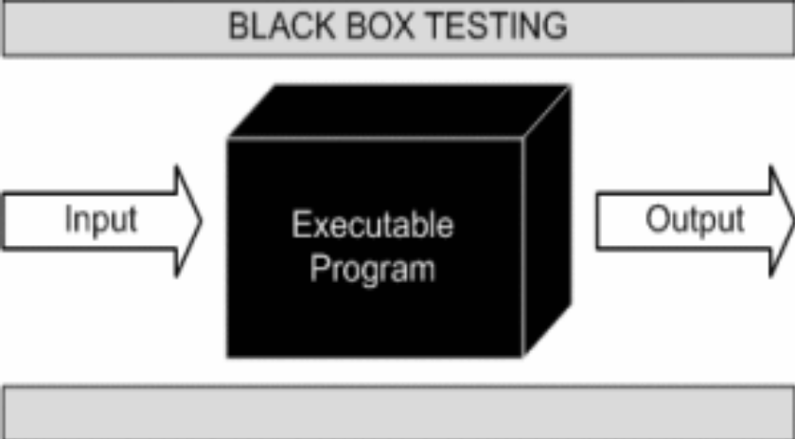

This method is named so because the software program, in the eyes of the tester, is like a black box; inside which one cannot see. This method attempts to find errors in the following categories:

- Incorrect or missing functions

- Interface errors

- Errors in data structures or external database access

- Behaviour or performance errors

- Initialization and termination errors.

White-Box Testing:

White Box Testing ,also known as Clear Box Testing, Open Box Testing, Glass Box Testing, Transparent Box Testing, Code-Based Testing or Structural Testing is a software testing method in which the internal structure/ design/ implementation of the item being tested is known to the tester.

The tester chooses inputs to exercise paths through the code and determines the appropriate outputs. Programming know-how and the implementation knowledge is essential.

White box testing is testing beyond the user interface and into the nitty-gritty of a system.
This method is named so because the software program, in the eyes of the tester, is like a white/ transparent box; inside which one clearly sees.

Limitations and Future Application of the Project

Futures Enhancement:
- In future we can expand this project on the web.
- In future, we can send messages to staff on phone about their schedule.

Limitation :
In this, we don’t block the staff.

Screen Snapshot

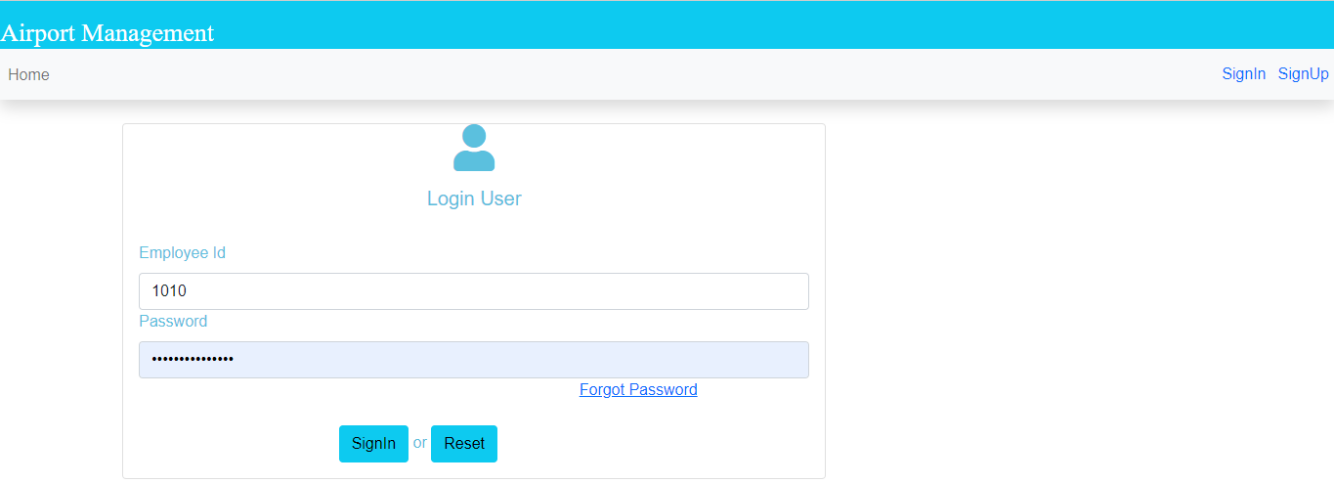
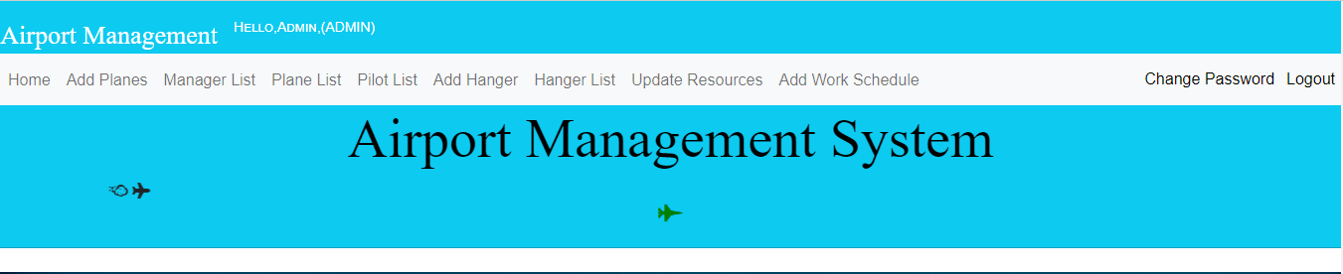
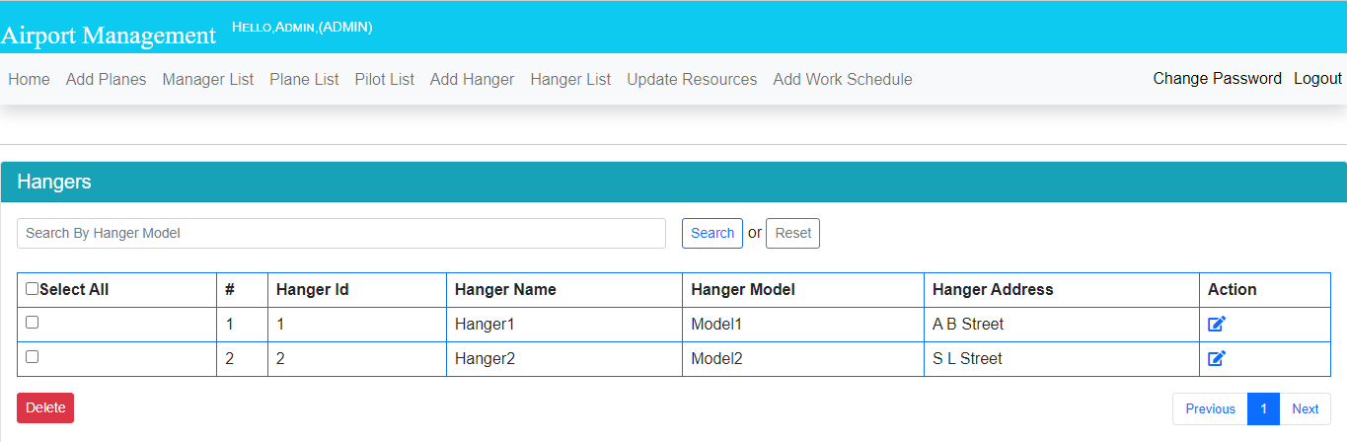
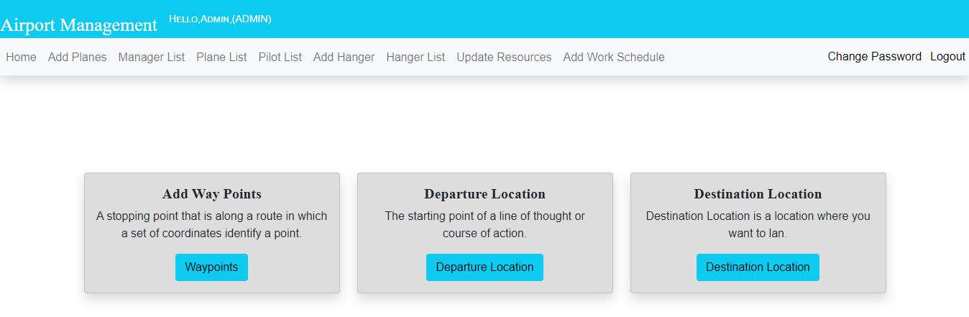
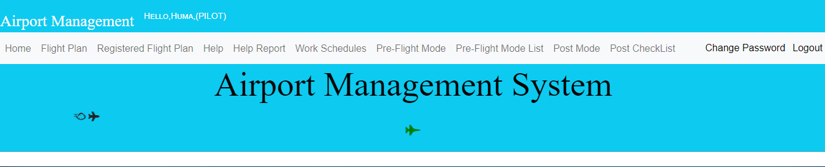
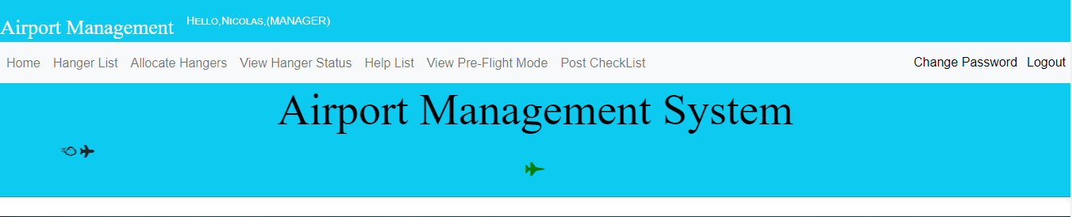

Conclusion

The Airport Management System will help the staff working at the airport to manage the airport-related activity efficiently. Here, Airport activity would be automated. The pilot and manager working at the airport would have a single gateway to connect.
This project can be used by the Airports who wants to have a common gateway and to have a multiuser application to connect with its employee and to manage the Flights.
This application is designed in such a way that any future modification can be done most easily.

